6.1 Vectors on a Plane

Before we get started, a vector is a line having direction as well as magnitude. Vectors go on forever, as any line would, but for calculation purposes we will look at vectors as directed line segments only.
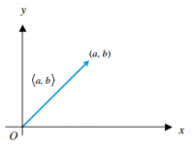
As a result, the section of a vector we are dealing with has an initial point and a terminal point . This is where the vector starts (usually, but not limited to, at the origin) and ends, respectively.
terminal point (head)

Vectors are written in component form, not to be confused with the vector’s endpoint, .
initial point (tail)

The Basics: Finding Equivalent Vectors (and vectors in general!)
Equivalent vectors are vectors with the same direction and magnitude. To start off your understanding of vectors, if you are given an initial point and a terminal point and told to find the resultant vector, use the Heads Minus Tails rule. This will become useful later as a part of finding vectors to project.
HMT rule: $\left(x_{2},{ y}_{2}\right)-\left(x_{1, } y_{1}\right)=〈\left(x_{2}-x_{1}\right), \left(y_{2}-y_{1}\right)〉$
the vector!
terminal point (head)
initial point (tail)

The Basics: Finding Magnitude
This is another topic that will be built upon and heavily used in vector computations. Magnitude tells the size, or in this situation, length of its object.
The formula for magnitude is $\left|v\right|=\sqrt{{\left(x_{2}-x_{1}\right)}^{2}+{\left(y_{2}-y_{1}\right)}^{2}}$, where $\left(x_{1}, { y}_{1}\right)$ is the initial point and $\left(x_{2}, { y}_{2}\right)$ is the terminal point of the vector.
Another way to write this is$\left|v\right|=\sqrt{a^{2}+b^{2}}$, where vector $v=〈a, b〉$. This method is more commonly applied.
The Basics: Vector Operations
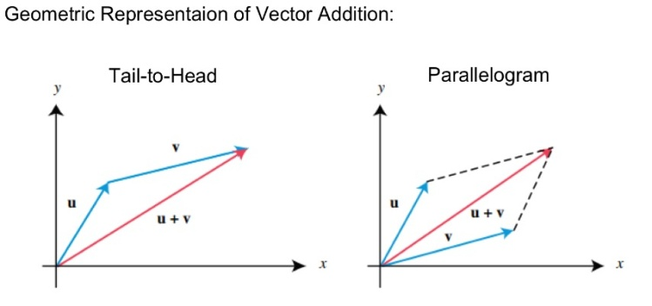
Where vector$u=〈u_{1}, u_{2}〉$, vector$v=〈v_{1}, v_{2}〉$, and k is a real number (scalar)...

The sum (or resultant) of the two vectors is: $u+v=〈\left(u_{1}+v_{1}\right), \left(u_{2}+v_{2}\right)〉$

And the product of the scalar k and the vector u is: $ku=k〈u_{1}, u_{2}〉=〈ku_{1}, {ku}_{2}〉$

Unit Vectors
A vector u with a magnitude $\left|u\right|=1$ is a unit vector. A vector v with a magnitude not equal to 1 can be converted into a unit vector u with the following formula:
*note: vector $v$ cannot be$〈0, 0〉$*

$$u=\frac{v}{\left|v\right|}=\frac{1}{\left|v\right|}v$$
If v is not the zero vector $〈0, 0〉$, then the vector u is a unit vector in the direction of v.

Example 1 (found on page 3 of 6.1 Vectors in a Plane guided class notes):
Find a unit vector in the direction of $v=〈-3, 2〉$
$unit vector in direction of v=\frac{〈-3,2〉}{\sqrt{{\left(-3\right)}^{2}+2^{2}}}=\frac{〈-3,2〉}{\sqrt{13}}= 〈\frac{-3}{\sqrt{13}},\frac{2}{\sqrt{13}}〉$

The standard unit vectors are: $i=〈1, 0〉$and $j=〈0, 1〉$
Any vector can be written as an expression in terms of standard unit vectors:
$$v=〈a, b〉$$
$$=〈a, 0〉+〈0, b〉$$
$$=a〈1, 0〉+b〈0, 1〉$$
$$=ai+bj$$
Horizontal component: $a$
Vertical Component: $b$
Component form: $〈a, b〉$
Linear Combination: $ai+bj$

Example 2 (textbook homework pg 464, #27):
Find the unit vector in the direction of vector $v$ when $v=〈-4, -5〉$. Write your answer in (a) component form and (b) as a linear combination.

First, find the magnitude of $v$
$\left|v\right|=\sqrt{{\left(-4\right)}^{2}+{\left(-5\right)}^{2}}=\sqrt{41}$

a) Therefore, the unit vector in component form is:
$〈\frac{-4}{\sqrt{41}}, \frac{-5}{\sqrt{41}}〉$
b) And the unit vector as a linear combination is:
$\frac{-4}{\sqrt{41}}i+\frac{-5}{\sqrt{41}}j$
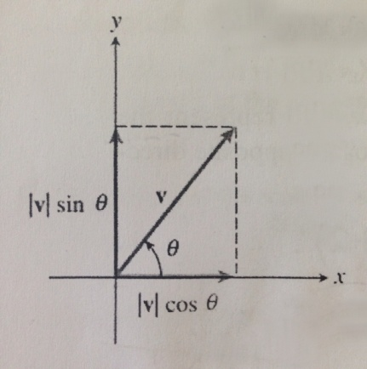
Direction Angles and Resolving Vectors
A vector’s direction angle is the angle from the positive x-axis to the vector itself.
If $v$ has a direction angle $θ$, the components of $v$ can be computed using the formula:
$$v=〈\left|v\right|\cos{θ}, \left|v\right|\sin{θ}〉$$
*For the formula above, it follows that the unit vector in the direction of $v$ is:
$$u=\frac{v}{\left|v\right|}=〈\cos{θ}, \sin{θ}〉$$

6.2 Vector Projection
Dot Products
The dot product of vectors $u$ and $v$, where vector $u=〈u_{1}, u_{2}〉$ and vector $v=〈v_{1}, v_{2}〉$ is:
$$u∙v=u_{1}v_{1}+u_{2}v_{2}$$
Properties of dot products (let u, v, and w be vectors, and let c be a scalar):
1. $u∙v=v∙u$
2. $u∙u=u^{2}$
3. $0∙u=0$
4. $u∙\left(v+w\right)=u∙v+u∙w$
$\left(u+v\right)∙w=u∙w+v∙w$
5. $\left(cu\right)∙v=u\left(cv\right)=c\left(u∙v\right)$

The Angle between Two Vectors *IMPORTANT*
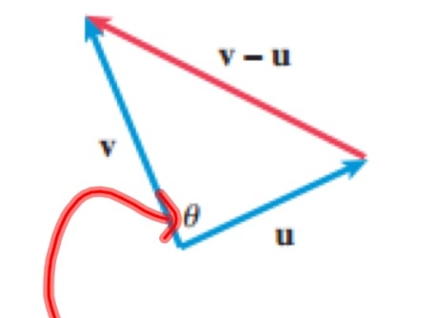
If $θ$ is the angle between two nonzero vectors $u$ and $v$, then:
$$\cos{θ}=\frac{u∙v}{\left|u\right|\left|v\right|}$$
And therefore
$$θ=\cos^{-1}\left(\frac{u∙v}{\left|u\right|\left|v\right|}\right)$$
Vectors $u$ and $v$ are orthogonal if and only if $u∙v=0$ (Hint: the angle between the two vectors will be 90˚)
Vectors $u$ and $v$ are parallel if the angle between them is 180˚

Projecting One Vector onto Another
If $u$ and $v$ are nonzero vectors, the projection of $u$ onto $v$ is:
Helpful reminders
(when projecting u onto v)
$$\cos{θ}=\frac{u∙v}{\left|u\right|\left|v\right|}$$
$$\left|u\right|\cos{θ}=\frac{u∙v}{\left|v\right|}$$
$${proj}_{v}u=\left(\frac{u∙v}{{\left|v\right|}^{2}}\right)v$$

You can also find the projection of $u$ onto $v$ by
using the formula:
$${proj}_{v}u= \left|u\right|\cos{θ}∙(unit vector of v)$$

Example 1 (number 9 from 6.2 Dot Product of Vectors Notes):
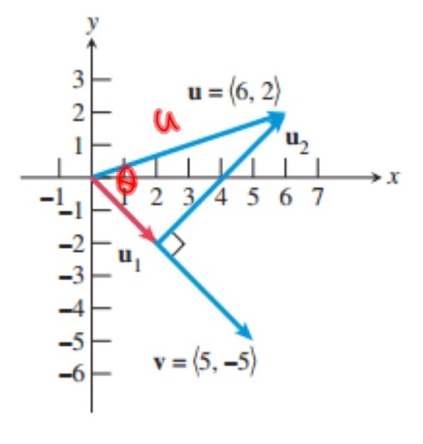
Find the vector projection of u onto v when $u=〈6, 2〉$ and $v=〈5, -5〉$

${proj}_{v}u= \left|u\right|\cos{θ}∙\left(unit vector of v\right)$

Looking back at the Helpful Reminders on the previous page, we see $\cos{θ}=\frac{u∙v}{\left|u\right|\left|v\right|}$, so we can substitute out $\cos{θ}$

$$\left|u\right|\left(\frac{u∙v}{\left|u\right|\left|v\right|}\right)∙\frac{v}{\left|v\right|}$$

We can now cancel out $\left|u\right|$ from the first term $\left|u\right|\left(\frac{u∙v}{\left|u\right|\left|v\right|}\right)$. We will also now plug in the appropriate values in the second term $\frac{v}{\left|v\right|}$ .

$$\left(\frac{u∙v}{\left|v\right|}\right)∙\frac{〈5, -5〉}{\sqrt{50}}$$

We will now substitute the appropriate values in the first term $\left(\frac{u∙v}{\left|v\right|}\right)$. The dot product of $u∙v$ is 20. If you do not understand how we got this value, review the content under the title Dot Product in Section 6.2.

$$\left(\frac{20}{\sqrt{50}}\right)∙\frac{〈5, -5〉}{\sqrt{50}}$$

Now, we simplify numerically.

$\frac{20〈5, -5〉}{50}=\frac{2}{5}〈5, -5〉=〈2, -2〉={proj}_{v}u$

Vector Applications
The best way to explain how to apply vectors in real-world situations is by going through an example to illustrate how the mathematical concept intertwines with real problems.
Let's go through some examples together:

Example 2 ("example 6" on page 5 of 6.2 dot Product of Vectors notes):
Juan is sitting on a sled on the side of a hill inclined at 45˚. The combined weight of Juan and the sled is 140 lbs. What force is required for Rafaela to keep the sled from sliding down the hill?
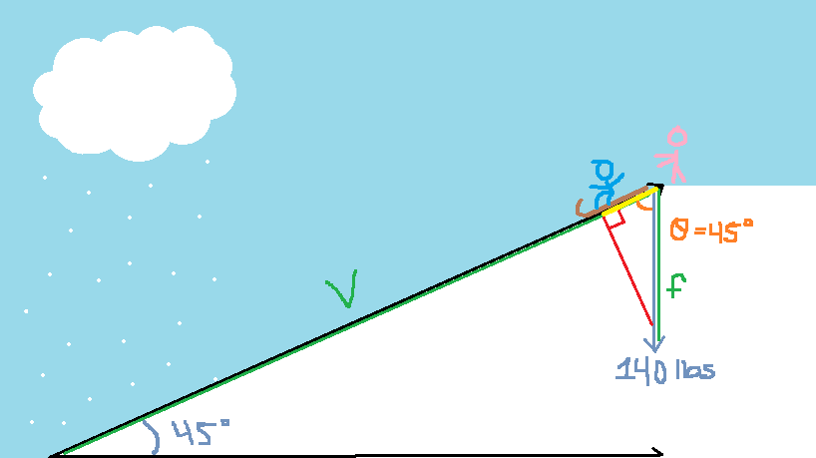
It helps to draw a picture first!
To find the weight in pounds Rafaela will have to pull to keep Juan from sledding, we must project vector f onto vector v (vectors labeled in green).
Therefore, we are finding the magnitude of the segment in yellow!!!

What we know so far:
The magnitude of vector $f$ is 140
Vector $f$ is $〈0,-140〉$ (because its direction is going directly downwards, vertically, with a force of 140 lbs)
The angle labeled in orange is $45°$ because the angle of the hill originally given to us (in blue) is $45°$. Therefore, the opposite interior angles theorem allows us to derive from this given that the orange angle is in fact also $45°$.
Since vector $v$'s direction angle is $45°$, vector $v$ in component form is written as $〈\frac{\sqrt{2}}{2},\frac{\sqrt{2}}{2}〉$ (this is derived from the Unit Circle!) This also means vector $v$’s magnitude is 1.

Now we can just plug values to the vector projection formula:
$proj_{v}f=\frac{-70\sqrt{2}}{1}×\frac{〈\frac{\sqrt{2}}{2},\frac{\sqrt{2}}{2}〉}{1}=〈-70,-70〉$
Now, find the magnitude of $〈-70,-70〉$.
$\left|f\right|=\sqrt{{\left(-70\right)}^{2}+{\left(-70\right)}^{2}}=99 lbs$
Rafaela would have to pull 99 pounds if she wishes to keep Juan from sledding.

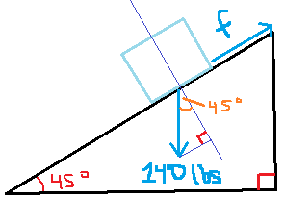
That process was pretty complicated, BUT there is an alternate method you can use to solve these problems: Mr. Kanuga's Method. He suggests drawing a diagram like the one below, and using the formula Force $=\left|f\right|sinθ$.

Force = $140sin45°=99lbs$

Vectors can also be applied in finding work. Work is measured in foot-lbs and given as
$$Work=Force×distance×\cos{θ}$$
with $θ$ being the angle between the force vector and the displacement vector (displacement vector: the shortest distance from the initial to the final position of a point).

Example 3 ("example 7" on page 5 of 6.2 Dot Product of Vectors Notes):
Find the work done by a force $F$ of 10 pounds acting in the direction $〈1,2〉$ in moving an object 3 feet.

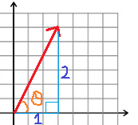
We know F = 10 lbs and D = 3 ft, so we are looking for $θ$.
We can find $θ$ by taking inverse tangent of $\frac{2}{1}$ :
$θ=tan^{-1}\left(\frac{2}{1}\right)$
$θ=63.43°$

Now plug all the variables into the work formula:
$Work=10×3×\cos{63.43°}$
$Work=13.4 ft-lbs$

6.3 Parametric Equations and Motion

In a parametric equation, x and y are functions of a third variable, also called the parameter, represented by t
We are used to seeing equations in Rectangular/Cartesian Form, $y=f(x)$, but a parametric equation is comprised of two parts: $x=g\left(t\right)$ and $y=f(t)$
The graph of the parametric equation is restricted it the parametric interval, which is $a≤t≤b$
Thus, the initial point on a parametric graph is (g(a), f(a)) and the terminal point is (g(b), f(b))

Example 1 (found on first page of 6.3 Parametric Equations and Motion guided class notes):
$x=t+1 y=t^{2}+2t; -3≤t≤2$

t | x | y
-3 | -2 | 3  $$x=t+1$$  $$→ t=x-1$$  $$→y={\left(x-1\right)}^{2}+2\left(x-1\right)$$  $$→y=x^{2}-1$$
-2 | -1 | 0
-1 | 0 | -1
0 | 1 | 0
1 | 2 | 3
2 | 3 | 8
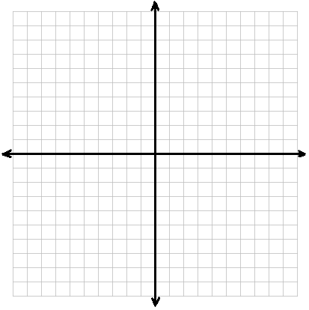
Terminal point
(3, 8)
10
10
Initial point
(-2, 3)
The Unit Circle
Parametric Form:
$x=\cos{θ}$
$y=\sin{θ}$

Cartesian/ Rectangular Form:
$\sin^{2}{θ+\cos^{2}{θ=1}}$ $→$
$y^{2}+x^{2}=1$ $→$
$x^{2}+y^{2}=1$

In order to convert an equation from parametric form to rectangular form, you must eliminate the parameter

Example 2 (number 1 in the 6.3 Parametric Equations and Motion guided class notes):
Eliminate the parameter when: $x=1-2t y=2-t; -∞≤t≤∞$
$y=2-t$ $→$
$y=2-\left(-\frac{x-1}{2}\right)$ $→$
$y=2+\left(\frac{x-1}{2}\right)$ $→$
$y=\frac{1}{2}x+\frac{3}{2}$
Domain: $-∞≤x≤∞$
$x=1-2t$ $→$
$x-1=-2t$ $→$
$$-\frac{x-1}{2}=t$$

Example 3 (number 2 on Quiz 6.3):
Eliminate the parameter and state the domain or range restriction if one exists. Describe the graph of the function. $x=3\cos{θ} , y=3\sin{θ} , 0≤t≤π$
As we can see based off the Cartesian formula for this equation, the shape of this graph will resemble a circle. However, the restrictions given to t translate to domain and range restrictions that we must take into account when finding our new graph. Finding the domain restrictions were easy; all you have to do is plug in the lowest and highest possible t values into the equation in order to find the lowest and highest possible values of x. However, in this situation, finding the range requires a bit more intuition. The y will hit its lowest possible value twice, once when the lowest possible t values is plugged in, and again when the highest possible t value is plugged in. Therefore, in order to find the highest point this graph will reach in terms of y, we have to plug in the t value that is the average of the highest and lowest t value.
$0≤t≤π$
$x=3\cos{0}$
$x=3\left(1\right)$
$x=3$
$x=3\cos{π}$
$x=3(-1)$
$x=-3$
D: $-3≤x≤3$
$\cos^{2}{θ}+\sin^{2}{θ}=1$
${\left(\frac{x}{3}\right)}^{2}+{\left(\frac{y}{3}\right)}^{2}=1$
$\frac{x^{2}}{9}+\frac{y^{2}}{9}=1$
$x^{2}+y^{2}=9$
$x=3\cos{θ}$
$y=3\sin{0}$
$y=3\left(0\right)$
$y=0$
$y=3\sin{π}$
$y=3\left(0\right)$
$y=0$

$\frac{x}{3}=\cos{θ}$
The graph is semi circle (laying above the x axis) with a center at (0,0) and a radius of 3
$y=3\sin{\frac{π}{2}}$
$y=3\left(1\right)$
$y=3$
R: $0≤y≤3$
$y=3\sin{θ}$
$\frac{y}{3}=\sin{θ}$

Example 4 (number 5 in the 6.3 Parametric Equations and Motion guided class notes):
Eliminate the parameter and graph. $x=-1+5\cos{t} y=2+2\sin{t}; 0≤t≤2π$
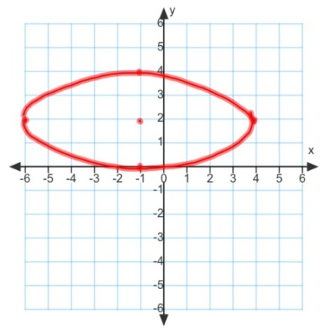
$\cos^{2}{θ}+\sin^{2}{θ}=1$
${\left(\frac{x+1}{5}\right)}^{2}+{\left(\frac{y-2}{2}\right)}^{2}=1$
$\frac{{(x+1)}^{2}}{25}+\frac{{(y-2)}^{2}}{4}=1$
$y=2+2\sin{t}$
$y-2=2\sin{t}$
$\frac{y-2}{2}=\sin{t}$
$x=-1+5\cos{t}$
$x+1=5\cos{t}$
$\frac{x+1}{5}=\cos{t}$

In application problems using parametric, you will often see problems involving parabolic and/or sinusoidal motion. Parabolic motion can be observed in problems where a projectile is being thrown (i.e. a baseball, an arrow, yard darts, etc.). Sinusoidal motion is commonly observed in problems dealing with circular motion (i.e. Ferris wheels, a dog on a leash/tether (running around in a circle), merry-go-rounds).
Using parametric equations to find the distance a projectile travels:
x(t) gives you the horizontal distance in relation to time and y(t) gives you the height in relation to time
$$let v_{0}=projectile^{'}s initial speed$$
$$let y_{0}=projectile^{'}s initial height$$

Parabolic Motion

Example 5 (number 1 from the 6.3 Parametric Application Notes)
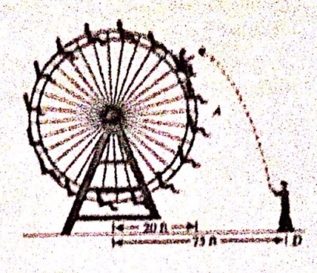
A 20 ft Ferris wheel turns counter clockwise one revolution every 12 seconds. Eric stands at point D, 75 ft from the base of the wheel. At the instant Jane is at point A, Eric throws the ball at the Ferris wheel, releasing it from the same height as the bottom of the wheel. If the ball's initial speed is 60 ft/sec and it is released at an angle of 60˚ with ,the horizontal, does Jane have a chance to catch the ball? Follow the steps below to obtain the answer.

a) What are the parametric equations $x_{1}$ and $y_{1}$, for Jane's path, in terms of time, $t$? Think of Jane as a point moving around the outer edge of a circle (the Ferris wheel).
$angular speed=\frac{2π}{12}=\frac{π}{6}$
$x\left(t\right)=x_{c}+r\cos\left(θt\right) y(t)=y_{c}+r\sin\left(θt\right)$

Sinusoidal Motion
let θ=angular speedlet xc=x coordinate of the circle's centerlet yc=y coordinate of the circle's centerx1=20cosπ6t
$y_{1}=20\sin\left(\frac{π}{6}t\right)+20$

b) What are the parametric equations $x_{2}$ and $y_{2}$, for the path of the ball, in terms of time, $t$? Think of the ball as a projectile being released at an angle.
$x_{2}=75-60\cos\left(60˚\right)t→x_{2}=75-30t$
$y_{2}=-16t^{2}+60\sin\left(60˚\right)t+0→y_{2}=-16t^{2}+30\sqrt{3}t$

c) Graph the two paths simultaneously and determine if Jane and the ball arrive at the point of intersection of the two paths at the same time.
First, make sure your calculator is in radian mode. Then, graph equations $x_{1}$ and $x_{2}$ (plugging them into the calculator as $y_{1}=20\cos\left(\frac{π}{6}x\right)$ and $y_{2}=75-30x$) and calculate the intersection point. You will end up with the approximate point $(2.2, 7.7)$. This means that when $20\cos\left(\frac{π}{6}t\right)=75-30t$, $t≈2.2 sec$. Therefore, Jane and the ball will arrive at the point of intersection after about 2.2 seconds.

d) Find a formula for the distance $d(t)$ between Jane and the ball at any time $t$.
${(x}_{1}, y_{1})=(20\cos\left(\frac{π}{6}t\right), 20\sin\left(\frac{π}{6}t\right)+20)$
${(x}_{2}, y_{2})=( 75-30t, -16t^{2}+30\sqrt{3})$
$$d=\sqrt{{\left(x_{2}-x_{1}\right)}^{2}+{\left(y_{2}-y_{1}\right)}^{2}}→$$
$d\left(t\right)=\sqrt{{\left(\left(75-30t\right)-\left(20\cos\left(\frac{π}{6}t\right)\right)\right)}^{2}+{\left(\left(-16t^{2}+30\sqrt{3}t\right)-\left(20\sin\left(\frac{π}{6}t\right)+20\right)\right)}^{2}}$

e) Use the graph of the parametric equations $x_{3}=t$, $y_{3}=d(t)$, to estimate the minimum distance between Jane and the ball and when it occurs. Do you think Jane has a chance to catch the ball? Why or why not?
***Graph the parametric equations $x_{3}=t$, $y_{3}=d(t)$ in the calculator. Based on your answer for section c of this question, you know the minimum occurs at about $t=2.2$. Therefore, use the Trace function on your calculator to find the ${(x}_{3}, y_{3})$ point that occurs when $t=2.2$. The $y_{3}$ value is the distance between the ball and Jane.
Jane and the ball will be closest to each other at about 2.2 seconds. At this time, they are about 1.642 ft away from each other, so Jane can in fact catch the ball.

6.4 Polar Coordinates

While rectangular coordinates are written in the format $\left(x, y\right)$, polar coordinates are written in the format $(r, θ)$, where r is the radius (distance from pole) and $θ$ is the angle of rotation from positive x axis

Example 1 (on page 1 of 6.4 Polar Coordinates Notes):
Plot the polar point $(2, \frac{4π}{3})$

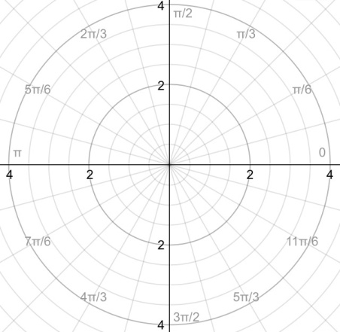
Polar coordinates are not unique, all other points found by using:
$\left(r, θ±2πn\right)$
or $\left(-r, θ±π\right)$ *Note: π, NOT πn*

Coordinate Conversion
Polar to Rectangular:
$x=r\cos{θ}$
$y=r\sin{θ}$

Rectangular to Polar:
$r^{2}=x^{2}+y^{2}$
$r=\sqrt{x^{2}+y^{2}}$
$θ=\tan^{-1}\left(\frac{y}{x}\right)$

*You can also use these conversion factors to convert polar equations to rectangular equations and vice versa*

6.5 Graphs of Polar Equations

Identifying Polar Graphs

Circle (6a and 7b from 6.5 Graphs of Polar Equations Application):
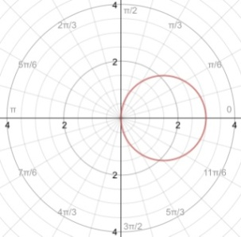$r=3\cos{θ}$ 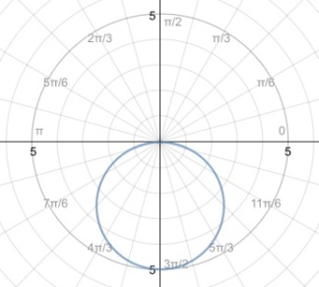$r=-5\sin{θ}$

Equation for a Rose Curve: $r=a\sin{nθ}$ AND $r=a\cos{nθ}$
When $n$ is odd, $n=number of petals$
When $n$ is even, $2n=number of petals$
When $\sin{nθ}$ is used, the first petal starts at $\frac{π}{2n}$
When $\cos{nθ}$ is used, the first petal starts on the polar axis (think x-axis)

Rose Curve (10a and 10b from 6.5 Graphs of Polar Equations Application):
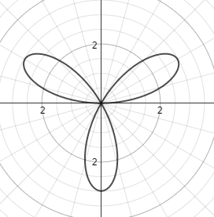$r=3\sin{3θ}$ 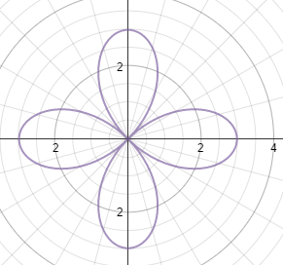$r=3\sin{2θ}$

Equation for a limacon: $r=a±b\sin{θ}$ AND $r=a±b\cos{θ}$

Limacon with a Loop (page 5 of 6.5 Graphs of Polar Equations Application):
*occurs when $\frac{a}{b}<1$
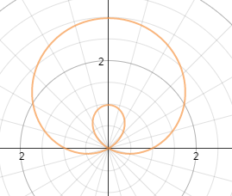$r=1+2\sin{θ}$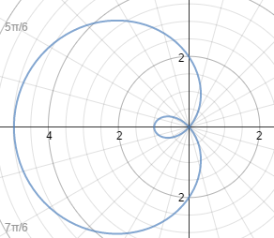$r=2-3\cos{θ}$

Cardioid Limacon (page 5 of 6.5 Graphs of Polar Equations Application):
*occurs when $\frac{a}{b}=1$
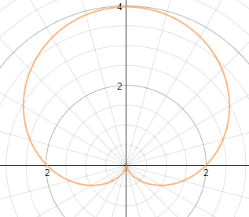$r=2+2\sin{θ}$ 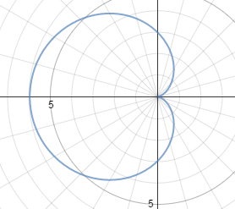$r=3-3\cos{θ}$

Limacon with a dimple (page 6 of 6.5 Graphs of Polar Equations Application):
*occurs when $1<\frac{a}{b}<2$
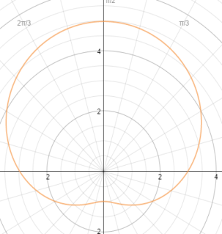$r=3+2\sin{θ}$ 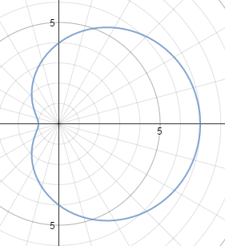$r=4+3\cos{θ}$

Convex Limacon (page 6 of 6.5 Graphs of Polar Equations Application):
*occurs when $\frac{a}{b}≥2$
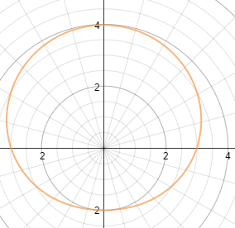$r=3+\sin{θ}$ 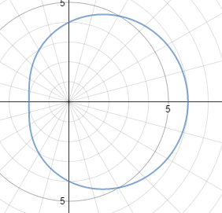$r=4+2\cos{θ}$
In limacons using $\sin{θ}$, the x-intercepts are $(±a, 0)$ and the y-intercepts are the sum/difference values of $a$ and $b$ (depending on the type of graph).
In limacons using $\cos{θ}$, the y-intercepts are $(0, ±a)$ and the x-intercepts are the sum/difference values of $a$ and $b$ (depending on the type of graph).

Equation for a lemniscate: $r^{2}=a^{2}\sin{2θ}$ AND $r^{2}=a^{2}\cos{2θ}$
Lemniscate (page 6 of 6.5 Graphs of Polar Equations Application):
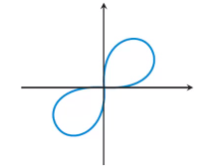$r^{2}=a^{2}\sin{2θ}$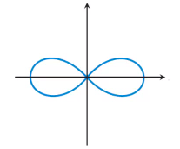$r^{2}=a^{2}\cos{2θ}$
6.6 DeMoivre’s Theorem
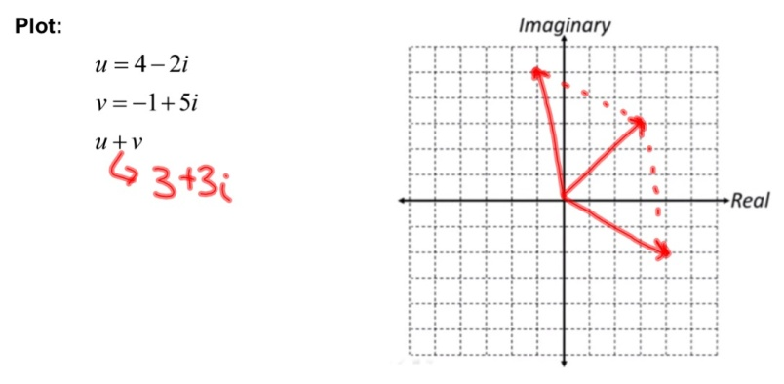
The Complex Number Plane

*remember, complex numbers are written in the form $a+bi$

The Absolute Value of a Complex Number
$z=a+bi$
$\left|z\right|=\sqrt{a^{2}+b^{2}}$
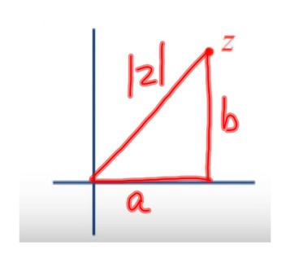

Trigonometric Form of Complex Numbers
Standard form: $a+bi$ Trigonometric Form: $r\left(\cos{θ}+i\sin{θ}\right)$
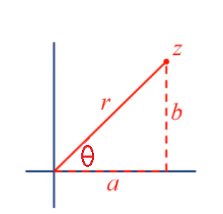
$a+bi$
$a=r\cos{θ}$; $b=r i\sin{θ}$
$r\cos{θ}+r i\sin{θ}$
$r\left(\cos{θ}+i\sin{θ}\right)$
Example 1 (#1 on 6.6 HW Quiz)
Write the trigonometric form of the complex number $3-3i$ where the argument satisfies: $0≤θ≤2π$.

$r=\sqrt{3^{2}+3^{2}}=\sqrt{18}=3\sqrt{2}$
$θ=\tan^{-1}{\frac{-3}{3}}=\tan^{-1}{-1}=-\frac{π}{4}=\frac{7π}{4}$
$r\left(\cos{θ}+i\sin{θ}\right)→3\sqrt{2}\left(\cos{\frac{7π}{4}}+i\sin{\frac{7π}{4}}\right)$

Example 2 (#2 on 6.6 HW Quiz)
Write the complex number $\sqrt{2}\left(\cos{\frac{7π}{6}}+i\sin{\frac{7π}{6}}\right)$ in standard form.

$\sqrt{2}\left(-\frac{\sqrt{3}}{2}-\frac{1}{2}i\right)$
$-\frac{\sqrt{6}}{2}-\frac{\sqrt{2}}{2}i$

Product and Quotient of Complex Numbers
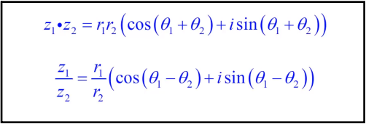

Example 3 ("a" on page 3 of 6.6 Polar Coordinates Notes):
Find $z_{1}∙z_{2}$ when $z_{1}=\sqrt{2}\left(\cos{\frac{π}{2}}+i\sin{\frac{π}{2}}\right)$ and $z_{2}=2\left(\cos{\frac{π}{4}}+i\sin{\frac{π}{4}}\right)$

$2\sqrt{2}\left(\cos\left(\frac{π}{2}+\frac{π}{4}\right)+i\sin\left(\frac{π}{2}+\frac{π}{4}\right)\right)$
$2\sqrt{2}\left(\cos\left(\frac{3π}{4}\right)+i\sin\left(\frac{3π}{4}\right)\right)$
$2\sqrt{2}\left(-\frac{\sqrt{2}}{2}+i\frac{\sqrt{2}}{2}\right)$
$-2+2i$

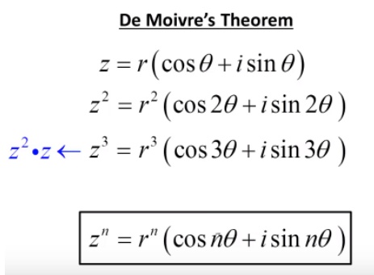
DeMoivre’s Theorem allows us to efficiently find the values of complex numbers to certain powers or the value of roots of complex numbers.
*Note: when finding the roots of complex numbers, the number of answers is equal to the degree of the root; i.e. When being asked for the fourth root of a complex number, there are 4 possible answers*
Example 4 (on page 4 of 6.6 Polar Coordinates Notes):
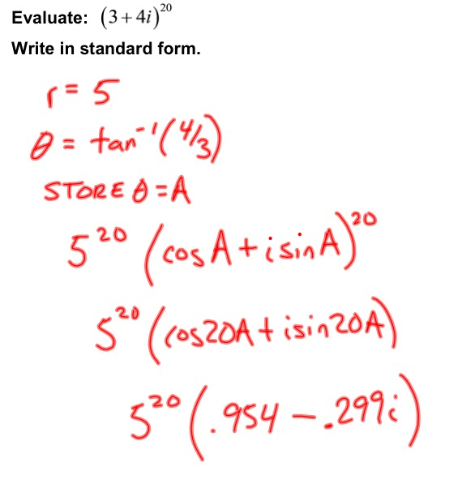

Example 5 (on page 5 of 6.6 Polar Coordinates Notes):
