HONORS PRECALC

Chapter 1 FUNCTIONS

1. **Modeling & Equation Solving**
2. (
3. a)increasing (b) 1974-1979
4. 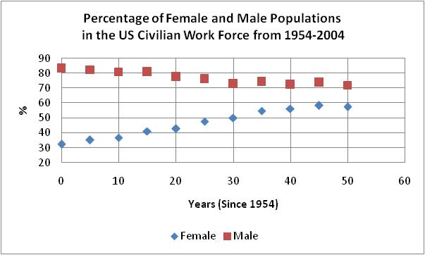
5. 
6. 2018, 70%
7. *x* = -22,0
8. *x* = -3,5
9. The jogger runs at a constant speed and completes two loops.
10. **Functions and their Properties**
11. yes

no, *y* has 2 values for each positive value of *x*.

5.



1. 
2. 
3. Range: (-∞, -1) [0,∞)
4. Local min: (2,2)

Local max: (-1,4), (5,5)

Increasing: (-∞, -1), (2,5)

Decreasing: (-1,2), (2, ∞)

1. Local min:(0.5, 3.75)
2. *x*=1 vert asym, *y*=1 horz asym
3. *x*=1, *x*=-1 vertical asymptotes

*y*=1 horizontal asymptote

1. *x*=2 vert asym, *y*=0 horz asym
2. **Composition of Functions**
3. 
4. 
5. Review in Class



1. 



1. **Graphical Transformations**
2. Shift right 100 & up 25
3. horz shrink ½, vert stretch 8
4. 
5. 
6. 
7. Review in Class
8. **Modeling with Functions**
9. Red: $19.80
10. 
11. 11.4 mph
12. **Quadratic Functions and Modeling**
13. V:(1,5), *x*=1
14. V:(-0.85,-6.08), *x*=0.85
15. *f(x)=* (*x*-2)2+2
16. *f(x)=2(x+1)2-3*